

ADDIS ABABA INSTITUTE OF TECHNOLOGY

School of Electrical and Computer Engineering

**PROJECT TITLE: SUPERHETRODYNE AM RECEIVER**

**TABLE OF CONTENTS:**

* **ABSTRACT**
* **INTRODUCTION**
* **PROJECT OBJECTIVES**
* **OPERATION OF EACH COMPONENTS**
* **DESIGN OF A SYSTEM**
* **OUTPUT OF A SYSTEM**
* **DISCUSSION**
* **CONCLUSION**
* **REFERENCES**

**ABSTRACT**

The AM stereo receiver system is a crucial component of a radio station's broadcasting equipment, allowing for high-quality, stereo audio transmission over the AM radio band. This system is designed to receive and demodulate the stereo signal from the station's broadcast source, using advanced signal processing techniques to achieve high fidelity audio reproduction. The system typically includes a range of components, such as a tuner, demodulator, stereo decoder, and audio amplifiers, all working together to deliver a high-quality stereo signal to the station's broadcast transmitter. AM stereo receiver systems are an essential tool for radio stations seeking to deliver high-quality audio content to their listeners, providing a superior listening experience that can help to attract and retain a loyal audience.

Here we are asked to design a basic AM-stereo receiver system that used in radio station by using Superheterodyne receiver system which should be able to demodulate and separate two information signals. The receiver is usually the most critical component of a wireless system, having the overall purpose of reliably recovering the desired signal from a wide spectrum of transmitting sources, interference , and noise.

A well designed radio receiver must provide several different functions :

* High gain (about 100dB) to restore the low power of the received signal to a level near its original baseband value.
* Selectivity, in order to receive the desired signal while rejecting adjacent channels, image frequencies, interference.
* Down conversion from the received RF frequency to a lower IF frequency for processing.
* Isolation from the transmitter to avoid saturation of receiver.
* Detection of the received information signal.

**INTRODUCTION**

Amplitude modulation (AM) radio is a common place technology today, and is standard in any type of commercial stereo device. Because of the low cost of the parts necessary to implement AM transmission and the simplicity of the underlying technology, using amplitude modulations is a cheap and effective way to perform many tasks that require wireless communication.

AM radio receivers are available in numerous devices, from automobile stereos to clock radios. However, the usage of AM transmitters is not restricted to professional radio stations.

In order to receive the signal, an AM receiver must be able to detect and demodulate AM signals. In the most primitive forms, this can be achieved by using a diode to rectify the signal, which cuts out half of the signal, and then use a capacitor to remove the carrier signal components.

AM (Amplitude Modulation) radio broadcasting has been around for over a century, providing an important source of information and entertainment for listeners around the world. However, the quality of the audio signal delivered by AM radio has historically been limited by the technical constraints of the system.

To address this limitation, AM Stereo broadcasting was introduced as a method to improve the audio quality of AM broadcasts. AM Stereo delivers a higher fidelity audio signal to listeners by transmitting two audio channels instead of just one. The system works by encoding the left and right audio channels onto two different carriers, which are then transmitted simultaneously over the same AM frequency.

An AM Stereo receiver is required to receive and decode the two audio channels, and separate them for output to two separate speakers. This allows listeners to enjoy a wider stereo soundstage and more detailed audio than would be possible with a standard AM radio broadcast.

AM Stereo technology has been in use for several decades, and while it has not been universally adopted, it remains an important tool for radio stations seeking to deliver high-quality audio to their listeners. Despite the emergence of newer digital radio broadcasting technologies, AM Stereo continues to offer a cost-effective way to enhance the listening experience for those who prefer to tune into traditional AM radio stations.

**PROJECT OBJECTIVES**

* To design the stereo AM receiver using simulation software.
* To see the practical application of the course rather than theory.
* To know detail about how the stereo AM is working.

A WORKING PRINCIPLE OF SUPERHETERODYNE RECEIVER

A typical Superheterodyne AM receiver comprises five components namely:

* a radio frequency amplifier,
* a wire antenna
* an IF section
* a mixer
* a demodulator (Envelope detector)
* a speaker
* a local oscillator

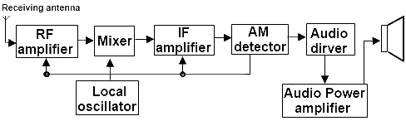

**OPERATION OF EACH COMPONENTS**

**Receiving Antenna**: A receiving antenna is a device used to pick up electromagnetic signals, such as radio waves, and convert them into electrical signals that can be processed and interpreted by an electronic device, such as a radio or a television.

The operation of a receiving antenna is based on the principle of electromagnetic induction. When an electromagnetic wave passes through the antenna, it induces an electrical current in the antenna's conductive material. This current is proportional to the strength of the incoming signal and the characteristics of the antenna.

The electrical current generated by the receiving antenna is then passed on to the receiver circuitry, where it is amplified and processed to extract the original information signal. The receiver circuitry may also filter out unwanted signals, such as noise and interference, to improve the quality of the received signal.

The design of a receiving antenna is critical to its performance. The antenna must be tuned to the frequency of the incoming signal to maximize its sensitivity and selectivity. The size, shape, and orientation of the antenna also play a crucial role in determining its efficiency and directional properties. For example, a directional antenna can be designed to pick up signals from a specific direction while rejecting signals from other directions.

Overall, the operation of a receiving antenna involves the conversion of electromagnetic waves into electrical signals, which are then processed and interpreted by an electronic device.

**RF amplifier**: An RF (radio frequency) amplifier in an AM stereo receiver is used to amplify the incoming signal from the antenna before it is demodulated to extract the audio signal. The RF amplifier is typically the first stage in the receiver and is responsible for amplifying the weak signal from the antenna to a level that can be easily processed by subsequent stages.

The RF amplifier operates in the radio frequency range, typically between 530 kHz and 1.7 MHz for AM broadcast signals. The amplifier circuit consists of one or more active devices such as transistors or vacuum tubes, which are used to amplify the signal.In an AM stereo receiver, the RF amplifier is designed to be linear, meaning that it amplifies all frequencies in the signal equally. This is important for maintaining the fidelity of the stereo signal, which is encoded in the amplitude of the carrier wave.

The RF amplifier may also include some filtering to remove unwanted signals, such as noise or interference from other stations. This helps to improve the signal-to-noise ratio and overall performance of the receiver.

Overall, the RF amplifier plays a critical role in the operation of an AM stereo receiver, amplifying and preparing the signal for subsequent processing to extract the stereo audio signal.

**Local Oscillator**: In an AM superheterodyne receiver, the local oscillator (LO) is an important component that generates a signal at a fixed frequency known as the intermediate frequency (IF). The LO's main purpose is to mix the received radio frequency (RF) signal with a locally generated frequency, resulting in an intermediate frequency that is easier to amplify and demodulate.

The LO operates on the principle of frequency mixing, also known as heterodyning. It generates a signal at a frequency that is close to, but not identical to, the received RF signal's frequency. This difference in frequency between the RF and LO signals is known as the intermediate frequency (IF). The LO's frequency is usually higher than the RF frequency, so the difference between the two signals is in the range of a few hundred kilohertz.

The LO's frequency is adjustable and is tuned to match the desired IF. The LO frequency is usually produced by an oscillator circuit consisting of a crystal or LC resonator, amplifiers, and frequency-determining components. The oscillator generates a high-frequency sine wave that is then passed through frequency-determining components like varactor diodes or adjustable capacitors to adjust the LO frequency.

The LO signal is then mixed with the RF signal in a mixer circuit. The mixer produces two output signals, the sum and the difference of the two input frequencies. The difference frequency is the desired intermediate frequency that contains the audio information in the AM signal. The sum frequency is typically filtered out since it is usually outside the receiver's bandwidth.

The resulting IF signal is then amplified and demodulated to extract the original audio signal from the AM modulated carrier wave. The LO frequency is critical to the performance of the receiver and must be stable, accurate, and free from noise or interference.

**Mixer**: A mixer is a fundamental component of a superheterodyne receiver, which is a type of radio receiver used to convert high-frequency radio signals to a lower intermediate frequency (IF) for easier and more accurate amplification and filtering. The mixer is responsible for the frequency conversion process that enables the superheterodyne receiver to achieve its high selectivity and sensitivity.

The mixer combines the received high-frequency radio signal with a local oscillator (LO) signal, generating a mixed output signal that contains both sum and difference frequencies. The LO signal is typically a fixed frequency oscillator signal that is tuned to a frequency slightly higher than the received radio signal frequency.

When the two signals are mixed, two new frequencies are generated - the sum and difference frequencies. The sum frequency is the sum of the two input frequencies, while the difference frequency is the difference between the two input frequencies. In the superheterodyne receiver, only the difference frequency is used as the intermediate frequency, while the sum frequency is filtered out and discarded.

The mixed output signal is then fed into a bandpass filter, which removes unwanted frequencies and passes only the intermediate frequency signal. This intermediate frequency signal is then amplified and processed in subsequent stages of the receiver to extract the original audio or data signal.

The mixer is typically implemented using diodes or transistors, which act as nonlinear elements that produce frequency mixing when they are biased with a local oscillator signal.

IF amplifier: An IF amplifier is a type of amplifier that amplifies intermediate-frequency signals, usually in the range of 10-30 MHz. It is typically used in communication circuits and radio receivers. The main function of the IF amplifier is to increase the signal strength before it is converted to a lower frequency so that it can be processed.

Envelope Detector: An envelope detector is a circuit used to extract the amplitude variations (envelope) of a modulated signal. It is commonly used in radio communication systems to demodulate amplitude modulation (AM) signals.

The operation of an envelope detector can be explained as follows:

* The modulated signal (which is an AM signal in this case) is fed to a diode which acts as a rectifier. The diode conducts current in one direction only, so it allows the positive half of the modulated signal to pass through while blocking the negative half.
* The output of the diode is a half-wave rectified signal, which still contains the carrier frequency of the modulated signal.
* To remove the carrier frequency, a low-pass filter (LPF) is used to smooth out the signal. The LPF allows only the low-frequency variations of the signal to pass through while blocking the high-frequency carrier.
* The output of the LPF is the envelope of the modulated signal, which represents the amplitude variations of the original modulating signal.

The resulting waveform is a smoothed version of the original modulating signal, with peaks that correspond to the positive peaks of the original signal. The envelope detector is a simple and effective way to extract the information contained in the amplitude variations of an AM signal.

**DESIGN OF A SYSTEM**

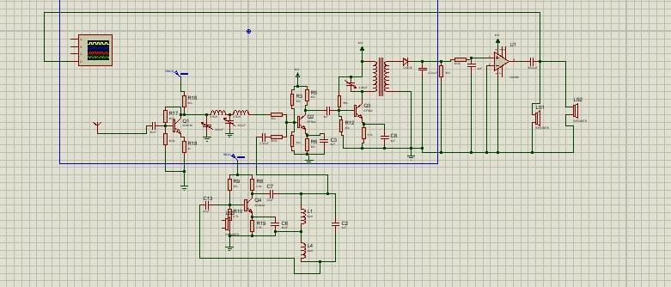

OUTPUT OF AM SUPERHETRODYNE RECEIVER

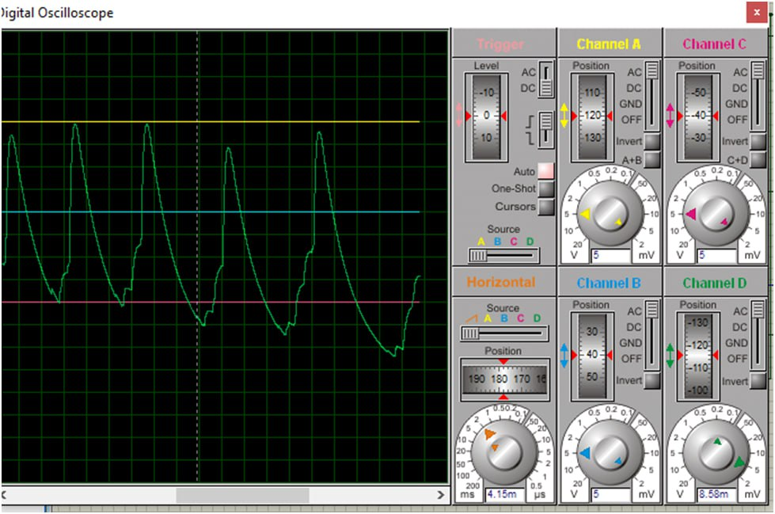

**DISCUSSION**

An AM superheterodyne receiver is a type of radio receiver that uses a combination of two or more frequency conversion stages to convert a signal from a higher frequency to a lower frequency. The superheterodyne receiver is the most widely used type of radio receiver, and is used in virtually all modern radio receivers.

The superheterodyne receiver works by first converting the incoming signal to a lower intermediate frequency (IF) using a mixer and local oscillator. The IF signal is then amplified and filtered before being sent to a detector, which extracts the audio signal from the IF signal. The audio signal is then amplified and sent to the speaker.

The main advantage of the superheterodyne receiver is its ability to reject unwanted signals. This is because the IF signal is much lower in frequency than the incoming signal, and therefore any signals that are not at the same frequency as the IF signal will be rejected. This makes the superheterodyne receiver much more selective than other types of receivers.

The superheterodyne receiver is also much more efficient than other types of receivers, as it requires less power to operate. This makes it ideal for use in portable radios and other low-power applications.

Overall, the superheterodyne receiver is a highly efficient and selective type of radio receiver, and is used in virtually all modern radio receivers.

**CONCLUSION**

A superheterodyne receiver uses signal mixing to convert the input radio signal into a steady intermediate frequency (IF) that can be worked with more easily than the original radio signal that has a different frequency, depending on the broadcasting station. The IF signal is then amplified by a strip of IF amplifiers and then fed into a detector that outputs the audio signal into an audio amplifier that powers the speaker. In this article, we will learn about the working of a Superheterodyne AM receiver or superhet for short with the help of a block diagram.

Most AM receivers found today are of superheterodyne type because they allow for the use of high selectivity filters in their Intermediate Frequency (IF) stages and they have high sensitivity (internal ferrite rod antennas can be used) due to the filters in the IF stage which helps them in getting rid of unwanted RF signals. Also, the IF amplifier strip providing high gain, good strong signal response because of the use of automatic gain control in amplifiers and ease of operation (only controls volume, power switch, and the tuning knob).

**REFERENCES**

* "Radio Receiver Design" by Kevin McClaning
* "Electronic Communication Systems" by Kennedy, Davis, and McMorrow
* "RF Circuit Design: Theory and Applications" by Reinhold Ludwig and Pavel Bretchko